MEMORANDUM | September 19, 2013

TO | Matt Keene and Scott Bowles, EPA
from | Daniel Kaufman, Nick Pittman, and Tracy Dyke-Redmond, IEc
subject | Repositories of Evidence Review

Introduction
Researchers and policymakers in many sectors, such as education, healthcare, and criminal justice, have compiled repositories of evidence to inform programs, policies, and interventions; however, such resources are limited in the environmental sector. The Environmental Evaluators Network, with support from the U.S. Environmental Protection Agency, is proposing to develop an Architecture of Environmental Evaluation (ArchEE) to meet the demand of for evidence related to environmental management. To inform this effort, IEc reviewed four well-established repositories of evidence identified by EPA. Our review identifies key features of the repositories and lessons that EPA could consider in developing ArchEE. This memo summarizes our findings, highlights similarities and differences across repositories, and describes how the repositories have evolved to better meet users’ needs. After describing similarities and differences across all four repositories, the memo describes each repository in more detail.
Scope of repositories
IEc reviewed four repositories:
- What Works Clearinghouse (WWC): Established in 2002 by the Institute of Education Sciences (IES) at the U.S. Department of Education, WWC aims to promote informed education decision making by providing schools, school districts, and education program developers with a central and trusted source of scientific evidence about “what works” in education.
- Campbell Collaboration (C2): C2 is a nonprofit organization that aims to help policymakers, practitioners, researchers, and the public make well-informed decisions about what works in the social, behavioral, and educational arenas. C2 conducts systematic reviews of studies of interventions, which it publishes in an online monograph series, and archives in C2’s online library.
- Crime Solutions: Crime Solutions provides evaluations of criminal justice-related programs and practices for practitioners and policymakers who are not social scientists. The review process and evidence ratings are meant to give users “access to social science evidence that is otherwise difficult for them to obtain.”
- International Initiative for Impact Evaluation (3ie): 3ie, a non-profit organization, funds evaluations and systematic reviews of development programs to “inform policy and improve lives of the poor.” In its dual role as funding agency and knowledge broker, 3ie assists researchers to carry out evaluations and communicate findings more effectively to influence policy.
IEc reviewed the four repositories on six dimensions: scope, information provided, format, functionality, accessibility, and design and evolution. The next section discusses similarities and differences across the four repositories; the last bullet point on page 2 describes their evolution.
Similarities and Differences Across Repositories
The four repositories that we reviewed share many features in common. They also have some differences, reflecting the sponsor’s decisions about scope, purpose, and accessibility. Major similarities and differences include the following:
- Scope: Three of the four repositories that we reviewed are dedicated to a single discipline (i.e., education, crime, or international development programs), and cover several topics within each discipline. Campbell Collaboration is the exception, covering social welfare, crime and justice, education, and international development. All four repositories aim to reach policymakers and practitioners and to inform evidence-based decision making. The repositories generally favor randomized control trials (RCTs) or quasi-experimental designs, but 3ie also includes qualitative research.
- Information: All four repositories go beyond simply archiving existing studies to critiquing and interpreting the research. WWC and Crime Solutions provide “evidence ratings” for research findings based on their assessment of the strengths and limitations of the methodologies. The other repositories do not provide ratings, but do provide reviews and critiques. The repositories include both individual studies and meta-analyses of research in a particular area.
- Format: The format varies depending on the type of report (e.g., single study or synthesis, quick or in-depth review). All four repositories include basic summary information, with links to full reports. In addition, WWC and Crime Solutions provide graphics that summarize the strength of evidence for each study or intervention.
- Functionality: The repositories all have search capabilities, some more advanced than others. All four allow users to conduct simple searches (type in keywords) or advanced searches (filter by topic, type of document, publication date, demographics, etc.). Users accessing WWC and Crime Solutions can search by evidence rating. C2 lets users save their search history for future reference. WWC and C2 let users export the search results and/or full publications to RIS, Excel, and/or PDF. Crime Solutions lets users send “program or practice profiles” to Facebook, Twitter, or Myspace. 3ei does not allow users to export search results.
- Accessibility: All four databases are open to the public, free of charge, and do not require registration. However, 3ie redirects users wishing to download the original research to an external website (e.g., online journal), which often requires payment to access the full article.
- Design and evolution: IEc identified the contractors who support: WWC (Mathematica), 3ie (Aptivate), and Crime Solutions (Lockheed Martin). Mathematica appears to provide content support, while Aptivate and Lockheed Martin provide Web design and technical support. We found information suggesting that three sites (WWC, C2, and Crime Solutions) have taken steps to enhance their services over time. C2 developed a more user-friendly and sophisticated search function, added new resources beyond the searchable library, and launched Danish, Japanese, and Chinese language versions of the site. Crime Solutions recently added a “practices” section in addition to its well-established “programs” section. WWC added more reviews to its website and began to consider quasi-experimental designs (previously it only considered RCTs) in an effort to increase the repository’s relevance and usefulness.
What Works Clearinghouse

Scope: The What Works Clearinghouse (WWC) was established in 2002, following the enactment of “No Child Left Behind,” as an initiative of the Institute of Education Sciences (IES) at the U.S. Department of Education. The WWC aims to promote informed education decision making by providing schools, school districts, and education program developers with a central and trusted source of scientific evidence about “what works” in education. WWC initially focused RCTs, but evolved to include quasi-experimental designs (see next page).
Information: The database includes over 9,500 research studies, along with WWC’s syntheses and critiques of the research. WWC classifies studies into 17 topic areas, which run the gamut from children with disabilities to college and career preparation. Four types of reports are provided: (1) practice guides provide recommendations to help educators address classroom challenges; (2) intervention reports summarize findings on an intervention to support evidence-based decisions; (3) single study reviews examine the research quality of a specific study; and (4) quick reviews provide the WWC’s assessment of recent education research. The “studies database” contains all WWC-reviewed studies.
Format: Each of the four publication types referenced above has a different format:
- Practice guides – Practice guides provide recommendations about particular education topics based on research. For each recommendation, WWC presents a “level of evidence” rating (minimal, moderate, or strong) and basic information about the research (topic, authors, release date, education level, audience, and related resources). The full guides are available in PDF format.
- Intervention reports – Each report has a summary page that includes: program description, the number of research studies reviewed by WWC, whether the studies meet WWC’s research standards, WWC’s “intervention effectiveness rating” (see Exhibit 1), link to the intervention report (PDF file), and links to related reports.
- Single study reviews – Summary pages provide a description of the study’s findings, release date, grades examined, review protocol, and citation. The reviews can be downloaded in PDF.
- Quick reviews – Quick reviews describe the study’s subject and findings, how the WWC rates the study, and a citation. Some have PDF links to the full review.
In addition, WWC provides current and previous versions of the Procedures and Standards Handbook – a detailed description of WWC’s protcol for reviewing the studies. The site also includes links to various social media forums, including RSS news feed and Facebook.
Functionality: The website facilitates four types of searches: (1) Search reviewed studies by topic, evidence rating, publication type, and /or keyword. (2) Search for RCTs by type of students covered in the research (race/ethnicity), grade level, type of learning disability, study status (funded and in progress, or completed), use of randomization (cluster or individual), and/or keyword. (3) Search for a reviewer (individual or organization, certification). (4) Search for an evaluator using the same parameters as the RCT search, plus geographic availability or content area focus.

Exhibit 1. Screenshot: WWC’s Intervention Effectiveness Rating for “Read Naturally”
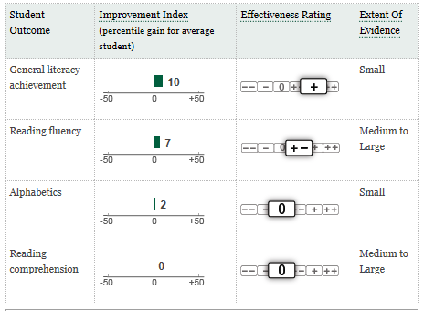
Source: WWC, http://ies.ed.gov/ncee/wwc/interventionreport.aspx?sid=407. Accessed 9-17-2013.
Search output varies by search type. Search results for reviewed studies include: study citation, WWC evidence rating, review protcol, and which report(s) the study is cited in. Search results can be exported to Excel. RCT search results include: title, status, start date, (propsoed) end date, sponsor, principal investigators, study setting, intervention, characteristics of study participants, design and analysis, outcome and summary, and related publications. The certified reviewers search and evaluator search include names and contact information for individuals and organizations that meet search parameters.
Accessibility: The website is free of charge to the public, and does not require registration. Summaries and full PDF files (when avaialble) are available for free download.
Design and evolution: It is not clear who actually built the website. Mathematica is referenced throughout the site, and Mathematica’s webpage states that the firm received a five-year contract “to administer the next generation of the WWC.” However, their role appears to focus on the publications/reviews and procedures/standards handbook, not the website architecture. From 2002 through mid-2007, the American Institutes of Research – the Washington-based research group that launched the clearinghouse – ran the site for five years.
WWC has evolved since its inception in 2002 in response to criticisms and its reputation as the “nothing works” clearinghouse, because few reviews were posted on its website and even fewer pointed to promising interventions. In an effort to boost its relevance and increase the amount of usable information it provides to the education community, the WWC loosened its research qualification standards and began to consider studies with non-experimental designs.
The Campbell Collaboration Library of Systematic Reviews
Scope: The Campbell Collaboration (C2) is a nonprofit organization that aims to help policymakers, practitioners, researchers, and the public make well-informed decisions about “what works” in the social, behavioral, and educational arenas. C2 conducts systematic reviews of studies of interventions (programs, practices, and policies) and publishes the results in a peer-reviewed, bimonthly, online monograph series. The reviews are archived in a searchable online database, the Campbell Collaboration Library. The reviews appear to favor RCTs, but include some quasi-experimental designs.
Information: C2’s online library houses roughly 100 completed reviews from 2002 through the present in four subject areas: social welfare (n = 40), crime and justice (n = 35), education (n = 17), and international development (n = 5). It contains information for an additional 124 reviews that are still in progress. Completed review proposals, review protocols, reviews, and user abstracts are posted online.
Format: Each “record” includes a summary page that lists the authors, publication date, topic area, monograph volume, issue number, and abstract. The full documents can be downloaded as PDFs.
Functionality: The online Campbell Library has two search options: simple and advanced. The simple search box at the top of the page allows users to enter search terms in a single text box, along with the option to select a field restrictor (all text, title, author, or keywords). The advanced search allows users to create more complex searches and provides a number of options for refining search results. Users can search by coordinating group (e.g., crime and justice), type of document (title, protocol, review, user abstract, other), and a range of publication years. Boolean selector pull-down boxes in front of the text boxes can be used to relate the search terms using the AND or OR operators. Exhibit 2 provides an example of an advanced search.
Exhibit 2. Advanced Search in Campbell Collaboration Library
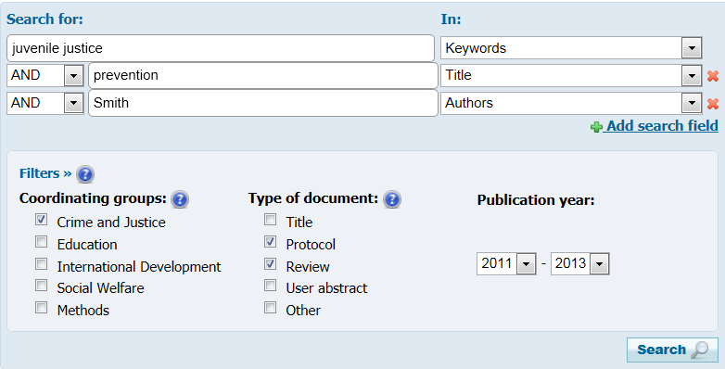
Source: http://www.campbellcollaboration.org/lib/?go=browse
Search results appear as a list of records that can be sorted alphabetically, by title, or by year of publication. The citations and full documents can be exported in RIS and PDF format, respectively. Users can also save their search history for future use.
Accessibility: All material in the Campbell Library is free to the public. Registration is not required.
Design and evolution: The repository is branded under Campbell Collaboration, and it is not clear what company actually designed the website. However, archives suggest that the website has been enhanced over time. For example, an archived news story on the website announces “a new and improved Campbell Library,” with a more user-friendly and sophisticated search function. Over time, C2 has added additional features to the website, including access to the Web pages of coordinating groups (e.g., crime and justice, education, international development, and social welfare), information about C2’s review process, and resources to support evidence-based decision making (under development). In addition, C2 has launched Danish, Japanese, and Chinese language versions of the website.

Crime Solutions
Scope: Crime Solutions provides evaluations of criminal justice-related programs and practices; the former denotes specific programs (i.e., “ABC Mentoring Program in Anytown, USA), while the latter denotes a general category of program (i.e., mentoring). Crime Solutions covers numerous aspects of the legal system, namely: Corrections and Reentry; Courts; Crime and Crime Prevention; Drugs and Substance Abuse; Juveniles; Law Enforcement; Technology and Forensics; and Victims and Victimization. Their evaluations use experimental and quasi-experimental designs, while their practice analyses employ meta-analyses of experimental and quasi-experimental designs.
Crime Solutions provides this information primarily for practitioners and policymakers who are not social scientists. The review process and evidence ratings are meant to give users “access to social science evidence that is otherwise difficult for them to obtain, and give them a basis for gauging the quality of evidence.”
Information: Crime Solutions provides extensive summaries of nearly 300 programs and 15 practices related to law enforcement. It also judges whether programs are “effective,” “promising,” or appear to have “no effects.”
Format: The “record” for each program includes: program description; evaluation outcomes; evaluation methodology; cost (if available); implementation information; evidence base (studies reviewed); and additional references. It also returns the evidence rating (i.e., effective, promising, or no effects). The “record” for each practice includes: practice description; meta-analysis outcomes; meta-analysis methodology; cost; evidence base (meta-analyses reviewed); additional references; and the evidence rating.
Functionality: The user can view all programs and practices on the “All Programs and Practices” page (see Exhibit 3), and can also sort based on evidence rating.
Crime Solutions’ advanced search option allows users to search programs (but not practices) by: keyword, evidence rating, topic, setting (delivery – e.g., inpatient/outpatient, home, etc.), age, gender, extent of evidence, program type, geography, race/ethnicity, and target population. Search results can be further sorted by title, evidence rating, topic, and summary. Users can send program or practice profiles to Facebook, Twitter, or Myspace.
The system currently lists 15 practices, which the user can filter by the same criteria available for the program advanced search (i.e., age, gender, targeted population, etc.).
Accessibility: All of the information is freely available. No registration is required.
Design and evolution: The Office of Justice Programs within the Department of Justice created Crime Solutions. The National Institute of Justice operates the repository and contracts with Development Services Group, Inc. to supply content and coordinate the evidence review process. Lockheed Martin provides website and technical support. The website originally contained only evaluations of specific programs, but recently added its practices section.
Exhibit 3: Screenshot: “Programs” List on Crime Solutions
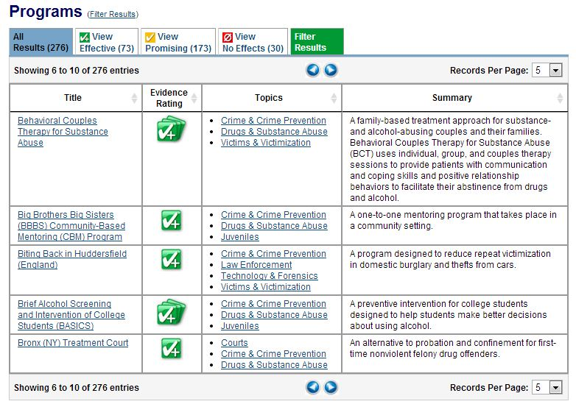

International Initiative for Impact Evaluation
Scope: The International Initiative for Impact Evaluation (3ie) is a non-profit organization based in Washington, DC. It operates programs in Delhi and London under the supervision of the Global Development Network and London International Development Centre, respectively. 3ie funds evaluations and systematic reviews of development programs to “inform policy and improve lives of the poor.” 3ie’s studies use a wide variety of evidence, both quantitative and qualitative. In its “dual role as funding agency and knowledge broker,” 3ie assists researchers carrying out evaluations in international development and helps them “better communicate the findings of their studies to influence policy.”
Information: 3ie supports three types of evaluation: (1) impact evaluations are summarized in 3ie’s Register of Impact Evaluation Published Studies (RIEPS), which “index[es] evaluations conducted in low- and middle-income countries”; (2) policy briefs, which include Evidence Matters (summaries of the most important evidence from systematic reviews), 3ie Briefs (examine the findings on overarching policy questions), and Policy Highlights (short briefs that look at key findings from three to five studies on a certain question); and (3) systematic reviews, which summarize reviews of social and economic programs carried out in low- and middle-income countries.
Format: Each of the three evaluation types referenced above has a different format:
- Impact Evaluations – Each Impact Evaluation page contains the methodology and main findings of the program, including a link to the external website where the article is published.
- Policy Briefs – Each Policy Brief page includes the study’s sector and region, with a brief summary of the review, question, findings, or group of studies in question.
- Systematic Reviews – Each Systematic Review contains: main findings, background, objective, methodology, quality assessment, and source link. It also includes a link to the original publication.
Functionality: Users can search RIEPS either with simple keywords or with an advanced search function (see Exhibit 4) that includes: title; author, sector (agricultural, economic, etc.), subsector, equity focus (elderly, refugee groups, etc.), evaluation method, country, region, status, and round of review. Search results appear as a list that is sortable by relevance and published date. However, users cannot export the evaluation citations.
Users can search Policy Briefs with simple keywords through a basic search or as part of a list of all briefs; there are slightly more than 60 briefs in total, listed in chronological order. Users cannot export the brief citations.
Users can search Systematic Reviews with either a simple keyword search or with an advanced option that includes the same options as RIEPS, except it has type (i.e., effectiveness review or other review) in place of country and evaluation method. Search results appear as a list sortable by relevance and published date. Again, users cannot export the review citations.
Accessibility: The site is free and fully accessible to the public; it does not require registration. However, users must pay to purchase many of the full articles from the journals that published them.
Design and evolution: Aptivate, a UK-based NGO that specializes in “Ethical IT for International Development,” built the website. It is not clear how the website has changed since its inception.
Exhibit 4: Advanced Search Function for Impact Evaluations
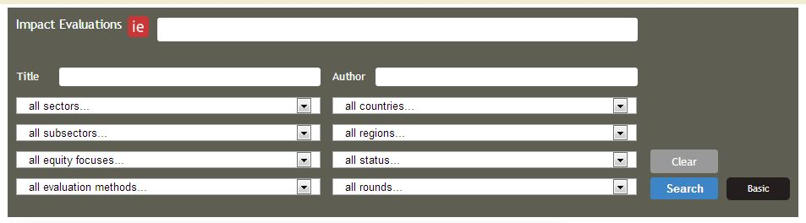

The California Evidence-based Clearinghouse for Child Welfare (CEBC4CW or CEBC)

Scope: The CEBC reviews existing programs in the areas selected by its Advisory Committee and examines the research evidence for programs and interventions for professionals who interact with children and families in the child welfare system. Some of their topic areas include anxiety treatment for children and adolescents, anger management for adults, teen pregnancy, and interventions for neglect. The data to support these programs come from a wide variety of sources and journals.

Summary: The CEBC indexes a large body of programs and interventions related to child welfare. Apart from summaries of these programs, the CEBC includes information on child welfare assessment tools, implementation resources, and online training resources.

Format: The detailed report for each program includes: scientific rating (1 through 5, 1 = “well-supported by research evidence,” 5 = “concerning practice”; it also includes NR, “not able to be rated”), child welfare system relevance level (low to high, indicating how similar the program clientele are to child welfare populations), brief program description, essential components of the program (i.e., continuity, leadership, etc.), child/adolescent services (i.e., how it helps children), parent/caregivers (i.e., how it helps them), group format (ideal size), recommended parameters (intensity and duration), delivery settings, homework (for program participants), languages, resources needed to run program, minimum provider qualifications, education and training resources, relevant published and peer-reviewed research, references, and contact information (for the program’s designer or chief proponent).

Functionality: The user can perform a basic search with keywords, or search by program name, topic area, scientific rating, child welfare outcomes, or child welfare system relevance. Some search results, such as topic area, are organized by scientific rating. The advanced search option lets the user combine the above parameters and adds age of child as a possible filter. All search functions return a list that cannot be sorted. As shown in Exhibit 1, the user can check a box to compare multiple studies side-by-side with descriptions of each program’s basic details, treatment details, and training details (i.e., for the provider).

Accessibility: The repository is free and fully accessible to all users with no registration required.

Design and evolution: California Department of Social Services selected the Chadwick Center for Children and Families – Rady Children’s Hospital – San Diego to create CEBC in partnership with the Child and Adolescent Services Research Center. It is not clear what company designed and built the repository.

Exhibit 1: Screenshot of comparison between two Programs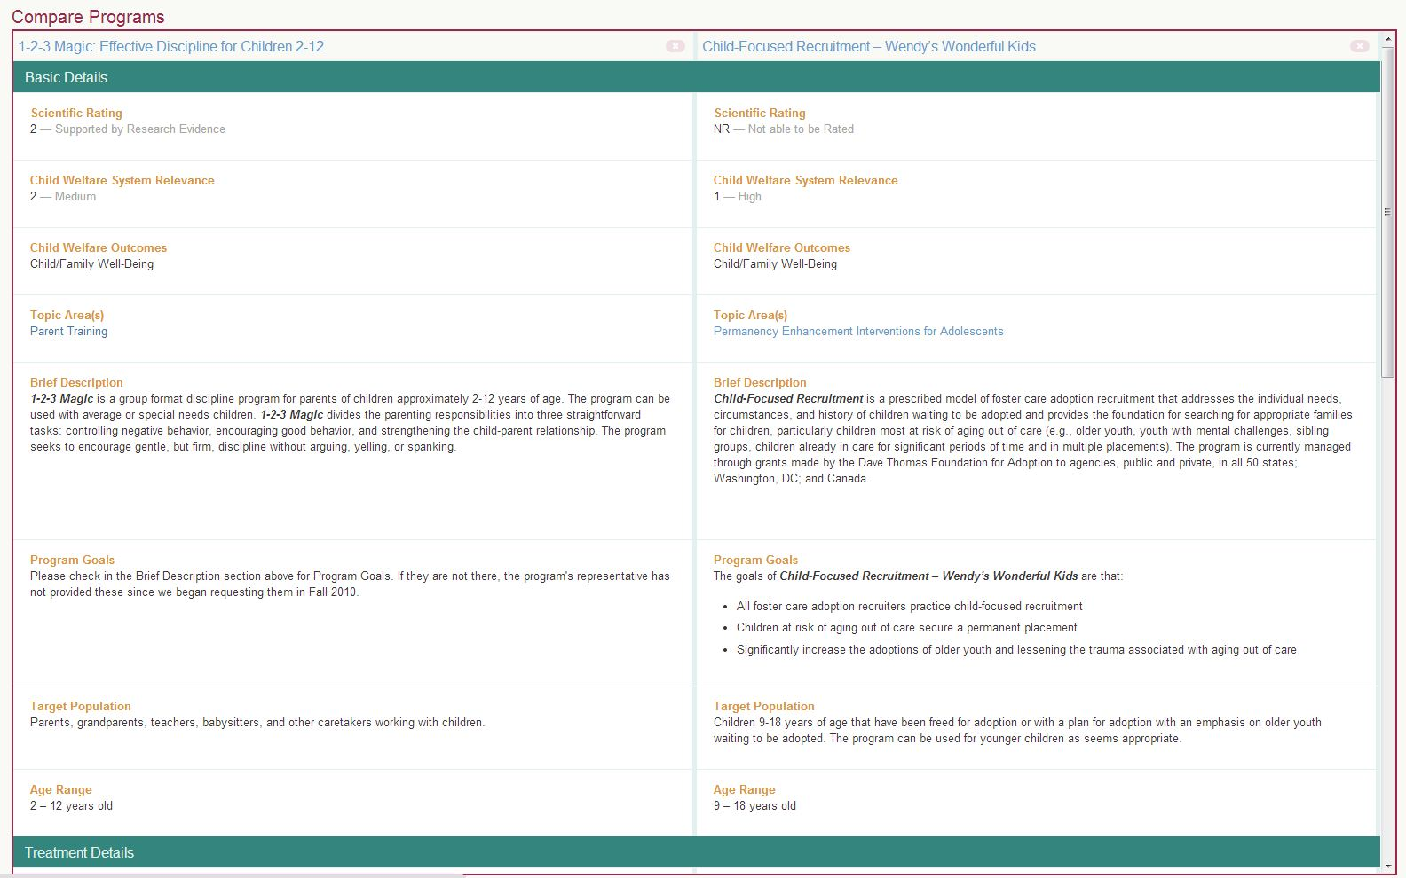

The Substance Abuse and Mental Health Service Administration (SAMHSA)’s National Registry of Evidence-based Programs and Practices (NREPP)

Scope: SAMHSA’s NREPP repository compiles information on interventions to support mental health promotion, substance abuse prevention, and mental health and substance abuse treatment. The site is meant to “connect members of the public to intervention developers so they can learn how to implement these approaches in their communities.”

Summary: NREPP provides in-depth summaries of over 300 interventions and programs meant to support various aspects of mental health. The site also includes summaries of nearly 70 “legacy programs,” older studies that have not been re-reviewed.

Format: The entry for each intervention begins with a one to three paragraph description of the intervention. The “descriptive information” section then lists: areas of interest (mental health promotion, substance abuse treatment, etc.), outcomes, outcome categories (homelessness, quality of life, etc.), ages, genders, races/ethnicities, settings (inpatient, residential, etc.), geographic locations, implementation history, NIH funding/CER studies (i.e., whether the study was at all funded by NIH, and whether it was evaluated in comparative effectiveness research studies), adaptations (to other age groups, locations, etc.), adverse effects, and Institute of Medicine prevention categories. The site includes expandable tabs under “Learn more” summarizing: quality of research (i.e., documents reviewed regarding the intervention, more detailed descriptions of the program’s outcomes and study population, and ratings for how well the intervention met its goals), readiness for dissemination (i.e., various materials needed for the program’s implementation, including their ranking for readiness), costs (i.e., the costs of the various aspects of the intervention), replications, and contact information.

The entries for legacy programs include a brief program description and contact information for the program developer.

Functionality: NREPP’s basic search function allows the user to search with a keyword or phrase. The advanced search function includes: keyword or phrase, gender, areas of interest, outcome categories, geographic locations, ages, races/ethnicities, and settings. These searches return a list of intervention titles with a short description of each one. As shown in Exhibit 1, the user can also select multiple interventions to compare in a table listing each intervention’s title, outcomes, ages, races/ethnicities, and settings. The user can filter the search results by the same categories available for the advanced search (i.e., gender or age of the intervention targets) as well as by NIH funding/CER studies and implementation (implemented internationally or replicated). Finally, the user can filter the results to only studies that have a Spanish translation available as a PDF. Additionally, the user can search a list of all 304 interventions, sorted alphabetically or by date posted.

Accessibility: The website is free and fully accessible to all users. Fifty-one of the 304 interventions have Spanish translations available.

Design and Evolution: NREPP is run by SAMHSA, part of the Department of Health and Human Services. The repository, originally called the National Registry of Effective Prevention Programs, began in 1997 as part of SAMHSA’s Center for Substance Abuse Prevention. It originally identified a subset of 150 programs as either Model, Effective, or Promising, but discontinued these designations in 2004 in favor of the current rating system (the website does not explain what led to this change). Programs previously called Model underwent a re-review and are included in the current system, while many previously deemed Effective or Promising are included on the Legacy Programs page.

Exhibit 1: Screenshot of example of intervention comparison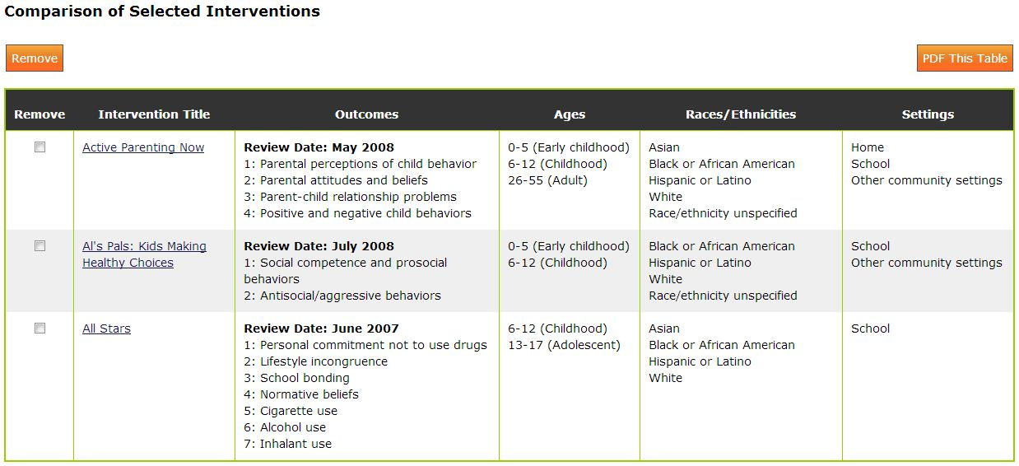

Veto Violence

Scope: Veto Violence’s Understanding Evidence program contains videos, infographics, and summary documents detailing evidence-based approaches to reducing various forms of violence, namely: child maltreatment, intimate partner violence, sexual violence, suicide, and youth violence. The site presents the majority of this content in the form of learning modules. The site is meant to offer “local practitioners and others working to prevent violence knowledge and resources for using evidence in their decision-making process.”

Summary: Four learning modules form the core of the website. The topics are: introduction to evidence-based decision-making, best available research evidence, experiential evidence, and contextual evidence. A Resource Center and a Continuum for Evidence of Effectiveness infographic provide other useful information.

Format: The user must take the modules in their prescribed order. At the start of each module an “accreditation” popup window details the program, course objectives, target audience, course presenters, course developers, and other information. Then, a video plays, after which a “knowledge check” popup window gives the user a brief quiz on the previous material. This video-knowledge check sequence repeats several times for each module. After completing the four modules, the user can register for Continuing Education credits.

The Continuum of Evidence of Effectiveness, shown below in Exhibit 1, displays the level of various criteria a study must meet to have its evidence considered “well supported,” “supported,” “promising direction/emerging/undetermined/more research needed,” “unsupported,” or “harmful.” Those criteria are: effect, internal validity, type of evidence/research design, independent replication, implementation guidance, and external and ecological validity.

The Resource Center, as shown in Exhibit 2, offers: videos (plays video in website); case studies (plays video in website); module summaries (opens PDFs); resources (opens popup window with useful links for resources, registries, resource centers, economic analysis, archival data analysis, community assessment, and experiential methods); glossary (opens popup window with important terms); and bonus materials (opens popup window with audio or text).

Functionality: Veto Violence does not have a search function like other repositories.

Accessibility: It is free to sign up for the website.

Design and Evolution: The CDC funds and supports the Understanding Evidence website. The website provides free continuing education through the International Association for Continuing Education and Training.

It is not clear how the website has evolved.

Exhibit 1: Screenshot of Continuum of Evidence of Effectiveness
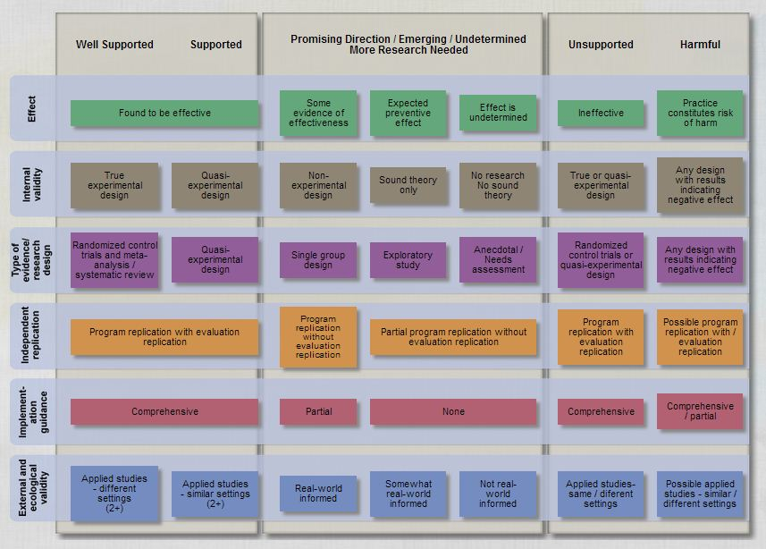
Exhibit 2: Screenshot of Resource Center
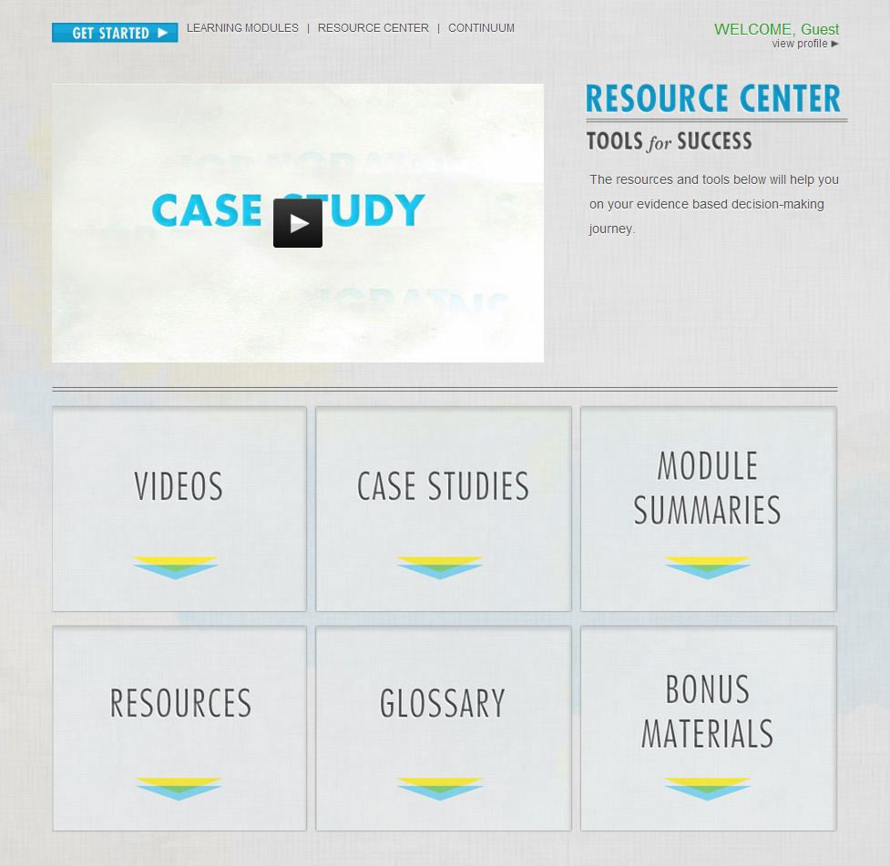

We did not find any information on the evolution of the 3ei repository website.
http://www.mathematica-mpr.com/education/whatworks.asp
Viadero, Debra. “Research Effort Aims to Bury ‘Nothing Works’ Image.” Education Week. December 15, 2008.
“What Works broadens its research standards.” AllBusiness.com. October 20, 2008.
Campbell Collaboration, “A new and improved Campbell Library!” Undated. http://www.campbellcollaboration.org/news_/new_Campbell_Library.php. Although the article is undated, the preceding and proceeding articles in the search results suggest the improvements were made, incrementally, between circa 2007 and 2009.
The URL is broken and it is unclear whether the Danish version of the website is still operational.
http://fuji.u-shizuoka-ken.ac.jp/~campbell/index.html
http://web.ntpu.edu.tw/~sjou/campbell/
https://www.crimesolutions.gov/about.aspx
https://www.crimesolutions.gov/about_tips.aspx
http://www.3ieimpact.org/en/about/
http://www.3ieimpact.org/en/about/what-3ie-does/
http://www.3ieimpact.org/en/evidence/impact-evaluations/
http://www.3ieimpact.org/en/evidence/policy-briefs/
http://www.3ieimpact.org/en/evidence/systematic-reviews/
http://www.aptivate.org/en/about/
http://www.cebc4cw.org/faqs/
http://www.nrepp.samhsa.gov/
http://www.nrepp.samhsa.gov/SearchLegacy.aspx
http://vetoviolence.cdc.gov/evidence/#&panel1-1
http://vetoviolence.cdc.gov/evidence/#&panel1-8
http://vetoviolence.cdc.gov/evidence/#&panel1-7

