Let’s Get Networked: Connecting Evaluation and Conservation Through Systems Thinking Imperial College London
Silwood Park Campus 26th to 29th August 2014

Day 2: Reflections and Expectations

Theme: Workshop process, led by Matt Keane
What is happening in conservation, evaluation, systems and why?
How do we vision what effective conservation would be?
What can we do to achieve the vision?

Use evaluation as a method by which to improve conservation employing a systems thinking approach

Conservation needs to be more effective yet is quite far behind other fields in how it is conceptualising and applying evaluation; systems thinking is the bridge to make conservation more effective

We need to apply evaluation and systems thinking in the context of conservation to provide greater understanding and techniques for use in conservation.

Theme: Workshop process, led by Cameron Norman
Concept: Mindfulness; provides a framework for navigating complexity and difference. Mindfulness is an ethical process of cultivating awareness through non-judgement, patience, trust, beginner’s mind, acceptance and humility.

Concept: Design
Everyone designs who seeks to take a situation and make it a better one
Designers don’t worry about what has been done but where they are going
A lot of designers have the qualities of mindfulness. Design is also emotional.

What are peoples’ feelings about evaluation, systems thinking and conservation?
Emotions provides the means for developing a story.

Emotions: frustrated, confused, impatient, unmindful, jetlag, anxiety, potential, pregnancy (desire to do & anxiety combination), tension, ignorance about what other people know and knowledge that we have and wanting to combine them, poised to do, frustrated, intimidation, optimism, excitement, interest/curiosity, fearfulness, overwhelmed, excitement, cynicism, hopeful, disillusionment, nervous, cautious, aware, aggression/intensity, connected, acceptance, urgency, expectant, cautious

Design is developmental so all the emotions won’t be remedied. There are some benefits to coming away with some reservations.

Brainstorm: What can we do to add constructive tension/resolution to the story that we are co-creating together?
- Move from process to content
- Explicit of our questions for each other
- Case studies – how to ground concepts
- Write out questions
- Reflect interests of those that are not present to overcome ‘what next’ frustration – think about other perspectives
- How to we re-package content so it is accessible to other audiences–making the current process useful and relevant
- Provide a storyline – beginning, middle and end, stories can speak to different people.
- Practical implications – can we find an evaluation framework that is useful to 100% of projects?

Ensure we come back to the above throughout the process to see if we are addressing.

Moving forward: Process to Content
What are the major challenges in conservation?
What is the biggest barrier to improving practice?

An excess of tools available, but there is no magic bullet tool. Focus should not be on tools but to understand what it is to think evaluatively and systemically.
Assess to what extent the current tools used can be modified and what are the questions people need to ask to arrive at the right tool.

Day 2: Helping each other understand what’s happening and why: Conservation

The History of Conservation, 3 minute lecture – Kent Redford

conservation with a small c was about maintaining natural resources for continued use. People who had control were able to exclude others from conservation to use the resources themselves; this took the form of hunting gardens

Modern Conservation is based on the notion of intrinsic value. National parks system established to take care of intrinsic value.

US version very centred on intrinsic rights. More recently demand has arisen from indigenous people that agency and power should lie with them.

Founded as a self-avowed crisis discipline and crisis is a central part of the narrative of conservation. People are the problem.

This set-up has caused several tensions:
- People as the threat
- Values vs. science – based on a value-based proposition but refused to recognise it
- Field came out of natural sciences – ‘conservation biology’, with the notion that data will solve the problem yet solutions lie in social science
- Many of practitioners of conservation are drawn from other fields and practice what many call ‘the art of conservation’ – this causes tensions with evaluation and how to evaluate an ‘art’

Further tensions brought to the table:
The practitioner and academic have moved further and further apart
Often ‘applied conservation’ does not lead to implementation and a fallacy has been created that far more of what we are doing is actually useful.

The Conservation discussion is overwritten by climate change, it receives large amounts of attention and it is where a lot of the money lies, but also the biggest failures. Failure is having feedback on the conservation community.

The Development and Conservation interface is causing tension as it is attempting to strike a win win situation. Win wins are hard to find and are often pushed in the agenda in the ways that aren’t appropriate. Raises the question of whether we are having the success in social issues that we think we are?

Tension between expectation of a scientific output and a practical output.
Tension between academic vs. applied as there are no rewards for engagement in the other.

From a South African perspective there is need to understand social and political as well as biological – ‘South Africa exceptionalism’

In Conservation we are trying to take learning’s from other fields but doing it badly; taking a tool out of context and destroying its’ utility.

Private individuals are often left out of the conversation. Payment for ecosystem services is the modern version of intrinsic value vs. utility.

There is an emerging interface with big business in Conservation. There is willingness within big business to engage with Conservation. NGOs are now influencing business practice.

Businesses are attempting to show net-positive impact. This requires making decisions regarding intrinsic value and consequently there are many calls for a meaningful metric of biodiversity loss and gain.

Synthetic biology has the potential to change outlook of whole field as it can create ecosystem services itself. Conservation should not create brittle boundaries as if we go down the ecosystem services/functional route too strongly it will create a problem when synthetic biology arrives.

There is the danger of always looking in the rear view mirror to measure success and in doing so we miss upcoming challenges

Q. Who pays for evaluation and who uses the output?
There haven’t been many evaluations. Business community moved into philanthropic community so there are more demands for accountability but there is no common currency on which return on investment can be assessed.

Sometimes there is a big push for accountability but then nothing is used going forward. Few donors include an allowance for evaluation. As there is no budget at the start, no baseline data collected so any evaluation is retrospective. Small NGOs have very limited capacity to conduct evaluation. Whilst some development funders ask us to talk about theory of change and evaluation in grant applications, very few have ask about it after the grant process.

Concept: Requirement to be genuinely evaluative and systemic
Need to think about evaluation as a process rather than a product. Evaluation strategies that are clearly customisable that can be built into design rather than being a design. Evaluation should never end; you should continually be evaluative about what you are doing and how you are doing it.

The CMP Open Standards for the Practice of Conservation provides a cycle that conservation has used to build an evaluative approach.

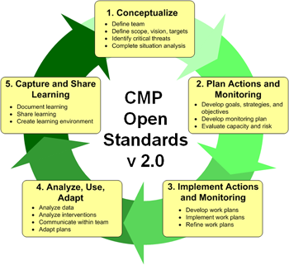

Source: The CMP Open Standards for the Practice of Conservation https://miradi.org/openstandards

Conservation started with implementing actions (stage 3) and then trying to grow at either end. Donors only ask for reporting on the first 3 stages.
The end of the cycle often does not happen, perhaps due to science challenging values; people are doing the only thing they know how so are reluctant to change that.

Part of the issues is donors own the results and nobody can learn if there is no permission to share.

The question should be: was it valuable? A project may have failed completely but did we learn or improve as a result of what we did?
Need to see the intervention in a systemic context; if we think in terms of A to B then we are set up to fail.

Day 2: Helping each other understand what’s happening and why: Evaluation

Overview of evaluation and its background, 3 minute lecture – Beverley Parsons

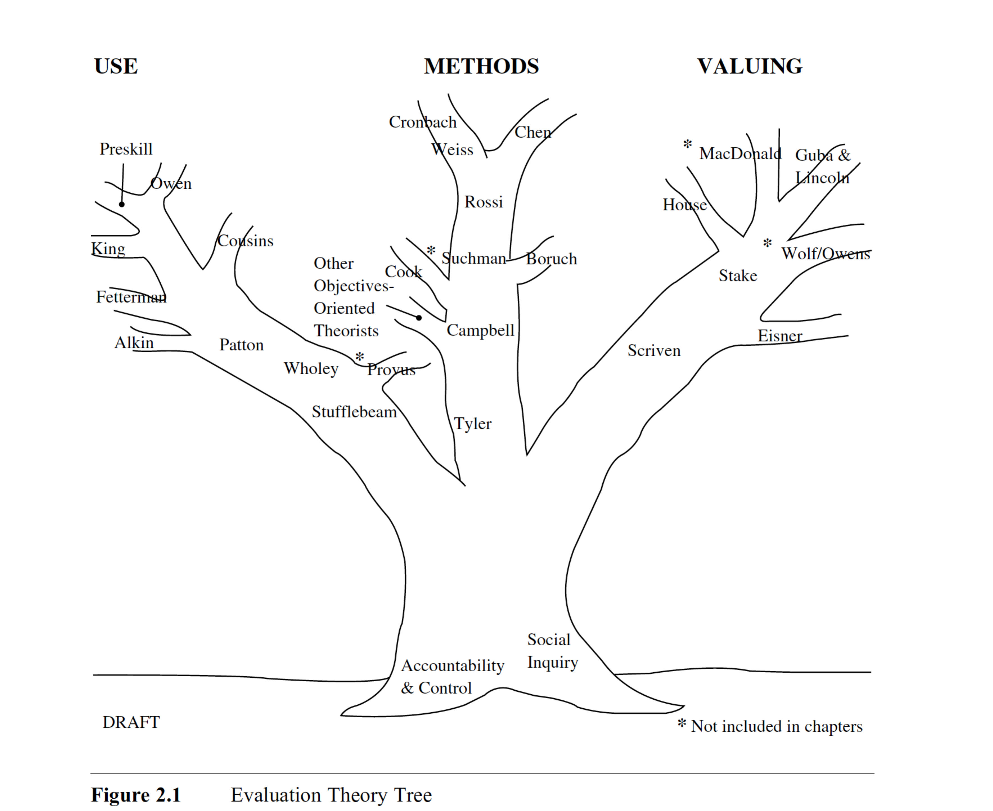

Source: Alkin, M. C., & Christie, C. A. (2004) An evaluation theory tree, 12–65.
Available from: http://www.sagepub.com/upm-data/5074_Alkin_Chapter_2.pdf

Whilst evaluation has always been around, as a discipline it is quite new.
The Evaluation Theory tree provides all the theories embedded in evaluation (from a North-American perspective). Three prominent theories have defined the evaluation field: (i) social accountability (ii) social inquiry (iii) epistemology.

Scriven focuses on merit, worth (values) and significance (importance) and the Scriven branch contain theories considering values.

The Campbell branch includes theories which focus on particular methods, a more qualitative route. Tyler was instrumental in how to measure within evaluation.

The Stufflebeam branch lies within applied science or practice. The use of evaluation (in decision-making, design or summative judgement).

The tree provides a general framework but it is culturally determined; there is different history in different areas.

The three areas that define the field are a heavy emphasis on understanding values, using variety of methods and doing it for some purpose. The practice of evaluation tends to fall in socially constructed systems, so there is different emphasis in methods dependent on the field. The circular system often falls apart because it doesn’t addressing meaning and use.

Funding is an important issue in evaluation as the field has been constrained by funding of what, when and how it evaluates; very project based.

Question: Why is there such widespread use of Randomised Control Tests (RCTs) which consume large amounts of resources?

Arises from the medical and agricultural field using non-human interactions, has been attempted to adapt to human interactions which appeals to policy makers.

Foreign aid has been driven for a long time on very specific projects, but a change came about in stepping back and funding entire programmes (capacity building). The certainty of success of projects is less clear when detached from the programme.
Evaluators weren’t providing reasons on why things were succeeding or failing. Economists wrote a book (what works/why things fail) using the RCT method.

RCT has become such a debate due to international development evaluation over the last decade. The international development community are trying to deal with uncertainty by oversimplifying a complex situation.
RCT is attractive because it is replicable.

We have talked a lot about specific projects, which are part of a big picture, but often we need to change the whole system rather than specific projects within the system.

Question: How can we decide upon the best method for evaluation for protected areas when there are two methods being used?

There is a need to decide on what is the value and to whom?/ the intended use for intended users.

Furthermore, research questions and evaluation questions should be distinguished. The utility of a research question, such as ‘did it work?’, is blurred. It may provide a general contribution but does not get to the real worth of the intervention.

There is a movement for Evidence-Based conservation; the survey and digestion of all available information to come up with a solution. But often there is no common ground for two situations.
In some fields (education as an example) there are lots of evaluations and they are useless in many ways as nobody is putting small evaluations together.

With RCT the results can be cherry picked to make comparisons and the most meaningful outcomes are not necessarily picked (just because they are significant doesn’t mean they are meaningful). This is driving the process by data without providing meaning.

There are a number of bodies collecting evidence of what works which include:
The What works clearinghouse (WWC) http://ies.ed.gov/ncee/wwc/
International Initiative for Impact Evaluation http://www.3ieimpact.org

Many of these collections assume the context doesn’t matter. What are the criteria that inform evidence? The Blair government put millions of pounds into evidence-based policy making to ask what evidence means? From the high level to the pragmatic: How do you design a literature review? What are the problems? Results fund that they are appalling bad at generating evidence of what works and what doesn’t. As a consequence designed a process for literature review.

Within Evidence-Based conservation the debate gets polarised but really evidence is very broadly defined with conservation context. In the search for methods that will bring together multiple contexts, where might evidence based with small letters fit within this approach?

RCT is a small unit and we need information about the system as a whole. We have a reductionist model as to how we learn but we need to understand a system first and how it fits together. We can then understand mixed-methods in a different way.
Michael pattern wanted to get a wider perspective so looked at common characteristics and principal factors, for example family health. The whole is an emergent pattern of the parts. Think about different relationship between the part and the whole.

Day 2: Helping each other understand what’s happening and why: Systems

Systems and systems application, 3 minute lecture – Glenda Eoyang

Every system has these three things but not in equal amounts:
Interrelations (exchange): lots and tight or few and loose
Perspectives (difference): may be concentrated into only one that will make any difference, or many ambiguous.
Boundaries (containers): few and closed or many and open

Or there could be different combinations of the above (lots of loose interrelations for example).

In the case of lots of tight interrelations, few and explicit perspectives, and few and closed boundaries; it would be appropriate to use an RCT and constrain the system in all these ways to get the data. You can constrain any system to get precise data but it does not mean it is accurate.

In an open, high-dimension and non-linear system, how do you define value & worth or know what you did made any difference?

‘Exploratory evaluation’ is a method to approach this. Find as many stakeholders as possible and ask about interrelations, perspectives and boundaries. Explore in any way that is likely to be informative for the situation to start to find interesting areas for use in the design phase. Example questions would be; who comes to you with a question? Who do you go to with a question? This encourages people to think systematically. Weak signals will often become apparent, listen for an outlier voice.

Pattern-recognition process: what are the similarities and differences in the system of what is important to people? Find common ground and rich differences.

Discussion as to where Conservation falls on the spectrum: suggested that Conservation interventions are attempted on the left hand side but employed on the right hand side.

The purpose is not to understand the system but plan for the next wise action in a complex system, ask what is the situation now? Then re-design. Providing tools to investigate a system systemically

If you find you are lost, then you have banded a system too broadly. Questions that should be asked are: Is X a part of the system I can influence/is it a variable in the system I influence? If X doesn’t play any of roles in the problem you are trying to solve, then it should be left out.

Data collection should be designed to start to address the next step. For example, bring two different groups together who wouldn’t usually talk to start the process of information sharing, to start evolving the system.
It is mot about the method you use but how you use the ones you have. There are only so many ways of undertaking enquiry so what we need to share is how we use the methods (evaluators/systems thinking don’t have a magic box).

A systems map:
- What are the parts?
- How do they interact?
- What differences make a difference?
- What methods fit to purpose?
Choosing the parts of the system that are relevant to your purpose.

There are different types of systems map but in all cases they are attempting to get a functional picture of the problem.

Day 2: Picturing conservation: What does it look like?

Juliet’s case study – Bushmeat consumption in Cameroon and Equatorial Guinea

Creating an influence diagram:
What is the key problem? (E.g. hunting of endangered primate species)
Look at influences that generate the problem
Look at how the problem influences other issues

Q. Do you start from the system or the intervention?
Use the intervention as the focal start point and then expand and then work backwards, have peripheral vision for other things.

Summary/explanation of process – Martin Reynolds
Map out the interrelationships then translate into another systems model of intervention.
See how interrelationships can be clustered and how the clusters influence others
Influences could be weighted using a thick arrow
Mapping the reality of intervention to engage with how to do the research and how to engage with different stakeholders
What’s the intervention about, how is it to be achieved and why it is necessary?
Different ways you can expand on system.

Relates to IPB (Interrelationships, perspectives and boundaries) by starting with interrelationships, and then making boundary judgements around perspectives and interrelationships.

Sam’s case study; Do the CBA maps inform the decision making process?

Relationships/influences map
What are the incentives?/motivations?/stakes?
Negative motivations as well as positive

Don’s case study: How do we stop the wildlife trade crisis? How to we conserve rhinos?

Militarisation of the parks creates a system change. Who’s bearing the costs? Values around who makes the decisions, who have the rights to make the decision?

In making a stamp shot of today, what’s relevant of history shows up but what’s not relevant disappears. Ask the questions: What does that connection look like? What does that boundary look like? How are they connected? Assume that if its important you’ll get to it.

Process:
- Need to do over and over again.
- Do this
- Say so what
- Take an action
- Stop and re-do
Sometimes 3 adaptive cycles required to break out of assumptions

