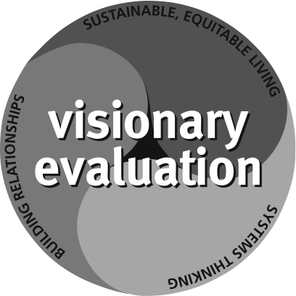**Visionary Evaluation  
 for a Sustainable, Equitable Future**

Let us use 2014 to tap the wisdom of systems thinking and our relationships to connect evaluation to the premier challenge of our time—nurturing a diverse and interconnected world with enough for all for generations to come. Let us envision evaluation as fundamental to a sustainable, equitable future.

AEA’s Guiding Principles call on evaluators to care for the public good, to “go beyond analysis of particular stakeholder interests to consider the welfare of society as a whole…[and to] consider not only immediate operations and outcomes of the evaluation but also the broad assumptions, implications, and potential side effects.”

Amidst intricate and interconnected challenges that threaten lives, livelihoods, and cultures, societies’ calls for transparency, accountability, and effectiveness are reverberating around the globe. Evaluators and evaluation users can serve the world by:

• **Understanding sustainable and equitable living.** Know the multiple languages of sustainability and equity. Understand the core issues, actions, and initiatives. Seek to make sense of its threats, opportunities, and ever-evolving form.

• **Integrating systems thinking.** Add a systems orientation to evaluation’s fundamental theory and practice to enable us to critique evaluation’s boundaries and understand multiple perspectives, diversity, relationships, and complexity. Use a systems orientation to detect influential patterns and trends over time and locations amidst the crowding noise of raw data. Systems thinking enriches evaluation—our questions, theories of change, methodological choices, communications, and the answers we offer.

• **Building relationships.** Enhance evaluation’s theories and practices by connecting with other spheres of life. Let us build stronger and new relationships with a greater diversity of disciplines, sectors, institutions, geographic regions, political perspectives and cultural traditions. To better serve the future, let us draw on – and contribute to – the wisdom of the world’s accumulating history.

Evaluation needs your understanding of sustainable and equitable living, integration of systems thinking, and intersection of relationships. How will you help evaluation to serve the world and its future? Consider these situations and questions:

• Since 1950, the world’s population has nearly tripled to over 7 billion…*Evaluation is used to determine the causes and effects of demographic change.* *How do you incorporate local or global demographics in your practice?*

• Societies are more productive than ever but consume natural and renewable resources faster than they can be replenished…*Evaluation can address the impact of policies on social and natural ecological systems. How are relationships between human and natural systems addressed in your evaluation work?*

• Flows of information, ideas, and capital are unprecedented…*Evaluation can study the merits of policies and programs regarding education, immigration, health, economics, and other social issues.* *How do social, political, technological, and institutional changes, at home and around the world, affect your evaluation learning, theory, and practice?*

• Malnutrition and poverty press on nations and neighborhoods…*Evaluation seeks to understand social interventions and innovations to enhance strategic learning and monitoring for long-term change. How do you use systems thinking and connect to previously untapped theories, professions, and cultures to answer questions about diversity and access related to nutrition, education, health care, and more?*

• Gender, social, and economic disparities and inequities persist…*Evaluation helps build the knowledge and theory that underpin equitable human action. How are you addressing values, perspectives, policies, norms, and structures that help make sense of these issues and support change?*

Let us, together, use systems thinking and our relationships to conceptualize visionary evaluation for a sustainable and equitable future. Bring your vision into 2014 and to the mile-high conference in Denver, Colorado. See you there!

**American Evaluation Association**

Beverly Parsons Matt Keene

2014 President 2014 Conference Program Chair