Summary of the 2012 Environmental Evaluators Network Unconference
'Environmental Evaluation in the Public Good'

Background

The Environmental Evaluators Network first annual forum was in 2006, with 90 participants. The forum was spearheaded with major logistical and monetary support from the Environmental Protection Agency (EPA). Other major sponsors have included the National Oceanic and Atmospheric Administration (NOAA), the National Fish and Wildlife Foundation (NFWF), National Aeronautics and Space Administration (NASA), George Washington University and Katholieke Universiteit in Leuven, Belgium. The forum has grown gradually over time, attracting an increasingly diverse crowd of environmental program managers and evaluators from around the country and world, with over 315 participants in 2011. There are EEN regional groups in the Canada, Europe, Latin America, and the United States –all of which host their own forums. Most recently, evaluators in Madagascar are starting a group.

In 2012, due in part to EPA budget and time constraints as well as a desire by top EEN organizers to try a different format, a core group of volunteers organized an 'unconference' format. Unconferences do not have set agendas beforehand. Instead, the ‘open space’ technology is driven by these rules: (1) whoever comes are the right people; (2) whenever it starts is the right time; (3) wherever it happens is the right place; (4) whatever happens is the only thing that could have happened; and (5) when it's over, it's over.

For the first time, the American Evaluation Association (AEA) was a major sponsor, taking the lead in the event's logistics. AEA was willing to participate so extensively due to their interest in non-traditional formats for exploring the theme, ‘Evaluation and the Public Good.’ Other sponsors in 2012 included EPA, NOAA, NFWF, Industrial Economics, Inc., George Washington University and Energy Markets, Inc.

The Unconference took place at American University on July 18th and 19th, 2012. A total of160 people registered for the Unconference, most representing U.S. federal and state government agencies ( e.g. EPA, NOAA, U.S. Fish and Wildlife Service), evaluation firms with environmental interests (e.g. Industrial Economics Inc.), university faculty, environmental not-for-profit organizations (e.g. Defenders of Wildlife, Trees for the Future), and private evaluation consulting businesses. Just over half of attendees had never attended an EEN forum before.

Activity before the Unconference

Environmental evaluators were invited to use the EEN Moderator website to blog ideas for conference sessions. Many ideas were submitted, including principles of design, evaluating projects designed to help communities adapt to climate change, common measurement, and the future of evaluation and EEN, most of which became one or more sessions at the Unconference. The opportunity to think and talk about sessions ahead of time allowed individuals to come to the conference prepared to discuss an issue, show an instrument, or present.

Like past EEN forums, attendees could attend low cost environmental evaluation training the day prior to the conference. The three training sessions offered in 2012 were Systems Thinking and Evaluation, Rapid Impact Evaluation, and Adaptive Management – Tools for Planning and Monitoring Conservation Projects.

The Unconference

The first day of the Unconference began with introductions and the basic outline for the two days of the event, followed by attendees’ descriptions of ideas for sessions they wanted to lead. Afterwards the sessions were scheduled on a matrix board, with columns representing room numbers and rows representing time slots.

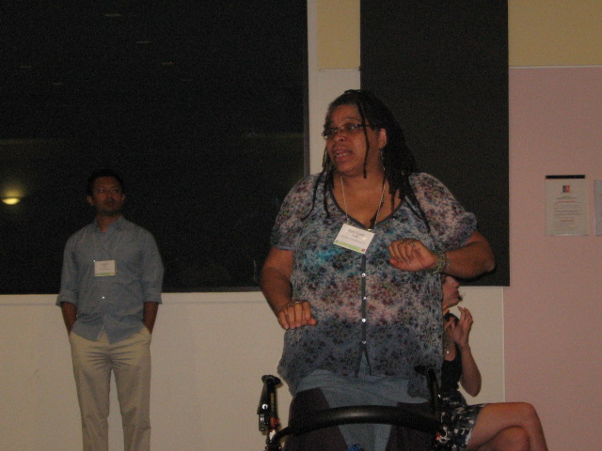
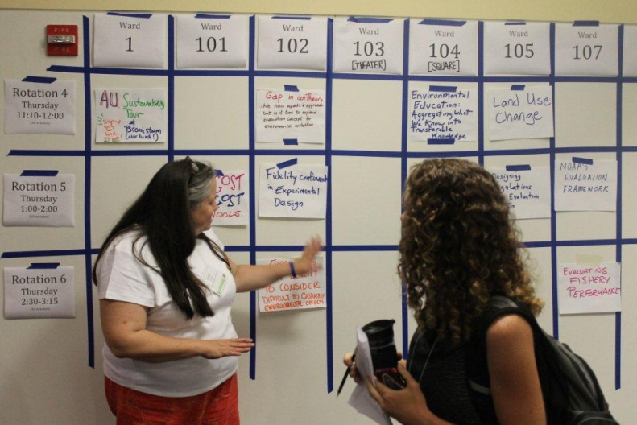

A total of 29 sessions took place:

- Social marketing / Communications eval / Measurement
- Evaluating internal collaboration
- Return On Investment: Sin? Savior? Both? Neither?
- Developmental evaluation (MQP 2010)
- Environmental education programs: What are we measuring?
- Evaluating landscape projects for lots of landowners
- Inspiring interest and dedication to “the work”
- Reinvigorate community well-being through evaluation
- Engage audiences with data visualization
- Fuzzy logic models
- Evaluators new to the evaluation field: What do we need to know?
- Use of evidence and evaluation in budget proposals
- Measuring compliance and enforcement
- Future of evaluation
- What is AEA’s role to support environmental consciousness and responsibility?
- Increasing evaluation adoption
- Evaluating public engagement online
- Low-cost, no-cost technology tools
- Future of EEN
- NOAA Evaluation framework
- Evaluation of unintended consequences
- Designing regulations with built-in evaluation
- RCTs: Pitfalls and Solutions
- Green products roundtable: Higher education pilot
- Climate change evaluation
- Web-based public engagement
- Landscape engagement of woodland owners
- AEA's role in supporting environmental evaluators
- Environmental education Part II

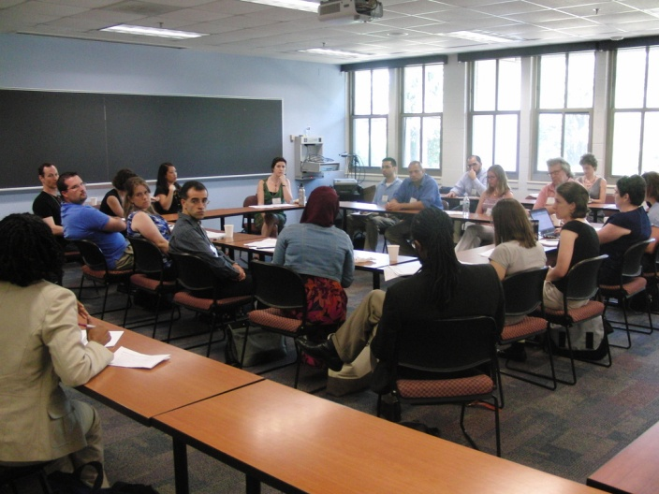

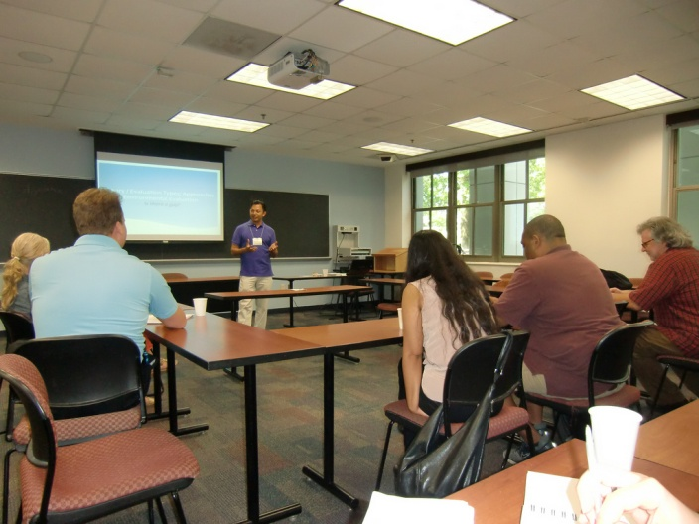

Some sessions consisted of formal presentations; in some attendees discussed a few key questions; and others were roundtable discussions. In addition, American University also hosted an optional field trip, sharing with attendees AU's intention to be carbon neutral by 2020 by reducing use, purchasing renewable energy, and off-setting; and there was one brown bag style lunch discussion regarding environmental evaluation and advocacy.

Most of these sessions had recorders, who documented themes discussed in the session, participation, and outcomes. The recorders perceived the great majority of sessions as being lively with participation by many attendees.

Some of the themes discussed across multiple sessions included:
- Appropriateness of particular methods (e.g. controlled trials, cost-benefit analysis, return on investment)
- Helping people to understand information (tailoring to audiences, visualization)
- Improving instrumental use of evaluation and avoiding misuse
- Common challenges in environmental programs and their evaluation (unclear program theory, unintended consequences, different values among stakeholders – even hostility among partners in some cases, time lag, time scales, feedback loops that are not well understood)
- Ensuring compliance systems are fair (measures are meaningful, well-defined, important/relevant)
- Evaluator competence (communities of practice, needed professional development, possible certification process )
- Evaluation in the world (fostering evaluation-friendly culture in agencies, expanding environmental evaluator network geographically)
- Environmental capacity building

In addition to sessions led by attendees, Office of Management and Budget Associate Director Shelly Metzenbaum gave a keynote address, explaining the OMB memo, 'Use of evidence and evaluation in the 2014 budget,' an initiative to deliver 'government that works' by requiring agencies to report their programs' effectiveness. Dr. Metzenbaum answered challenging questions posed by environmental and evaluation leaders.

As always, the conference allowed plenty of time for informal discussion and socializing!

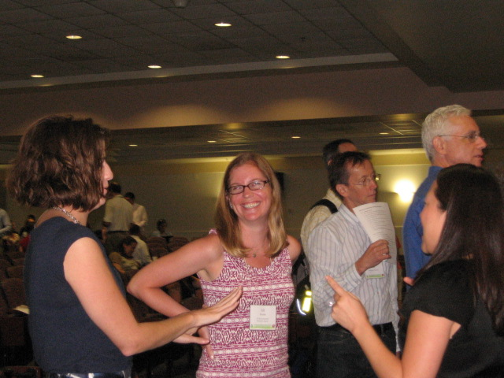

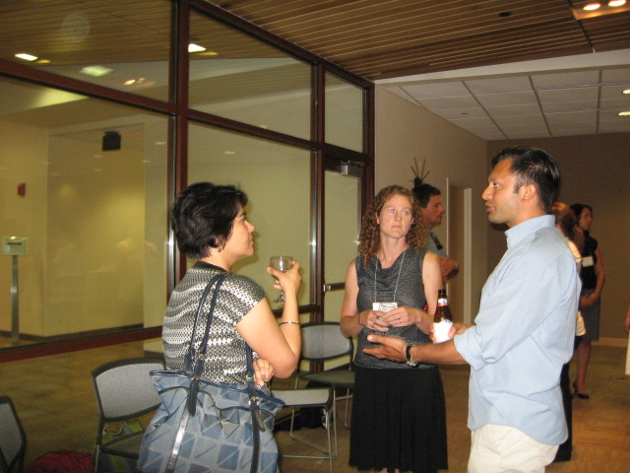

Participants at the conference reported being inspired by:
- Willingness of participants to share expertise and contributed to conversations
- Data topic books
- Level of thoughtful discussion
- Strength we have to create something new and bring that to broader evaluation field. This conference has not been about staking claims or bragging.
- We are not alone; valid expertise of colleagues
- Deep questioning of assumptions in the field
- Intergenerational participants, with young people willing to contribute, take risks, work in pulling things together

At the end of the Unconference, a number of ‘Special Topics’ were organized. Descriptions , project leaders, and team members are listed on the EEN website (http://www.environmentalevaluators.net/category/een-special-projects/):

- Carrying the EEN Torch into 2013: Forums, Governance, and Outreach
- An EEN Repository: Finding and Using Environmental Evaluation
- Environmental Evaluation: Theory Gaps
- Datapalooza: Unlocking Data in the Environmental Sector
- Welcoming Madagascar to the Environmental Evaluators Network
- EEN Coordination: Opportunities for the US and Europe
- Compliance and Enforcement: Research and Evaluation Exchange
The Special Topics continue to evolve as people add new ideas and projects are completed.

In July and August, participants completed a follow-up survey about their experiences at EEN. The great majority reported the experience was valuable and they were able to network with others. Open-ended comments suggest participants also appreciated the fluidity and active participation of attendees encouraged by the unconference format. Many participants also appreciated the content of the conference, especially the keynote address. Participants were less likely to respond that they had learned about evaluation methods and approaches. Many would have preferred at least somewhat more structure as well as more sessions/ less ‘downtime’ (though this implies a trade-off with the popular ‘networking’ time.) These findings suggest (as, indeed, several people suggested) a mixed conference/unconference format for future EEN forums.

