what was

LOS ANGELES

before the SPANISH??

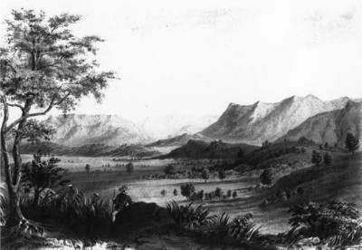
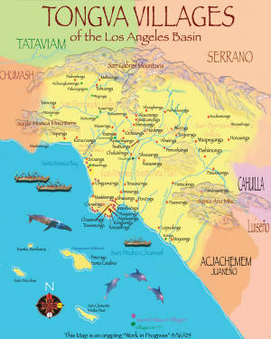
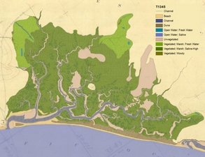
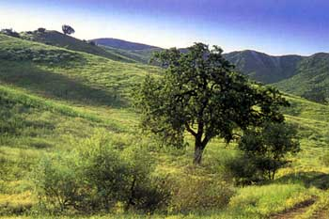
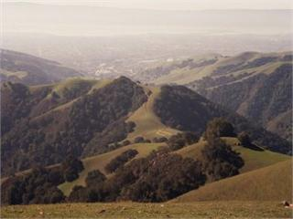
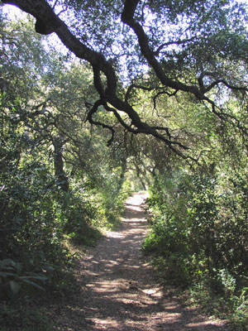
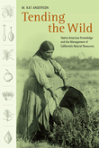 Tongva & Chumash

framework

HUMAN ECOLOGY

sphere (system)
level metrics ?

LIFE CYCLE ASSESSMENT
ECOLOGICAL FOOTPRINT

The following websites were visited and discussed in this presentation:

Welikia 1609 Map
Standards Overview | Project Management Institute
Standards Overview | Project Management Institute
Global Sustainability Community of Practice - Home | Project Management Institute
Life cycle assessment - Wikipedia, the free encyclopedia
life cyle assessment wikipedia - Google Search
International Society for Industrial Ecology - ISIE 2011
7th Grade: The Education and the Environment Initiative (EEI) Curriculum
The EEI Curriculum: Education and the Environment Initiative
Welikia Project | About this block
Welikia Project | About this block
Welikia Project | About this block
Welikia Project | About this block
Welikia Project | About this block
The Welikia Project » Welikia Map
Plone —
los angeles nature - Google Search
Google Images
http://www.google.com/search?q=los+angeles+nature&um=1&ie=UTF-8&tbm=isch&source=og&sa=N&hl=en&tab=wi&biw=1280&bih=709
los angeles nature - Google Search
los angeles nature - Google Search
PMI Communities of Practice | Project Management Institute
PMI Chapters and Communities of Practice | Project Management Institute
Good Things Happen when you Get Involved with PMI
Knowledge Center | Project Management Institute
PMI - the World’s Leading Professional Association for Project Management
PMI - the World’s Leading Professional Association for Project Management
project program management - Google Search
2011 Bioneers Conference —
2011 Bioneers Conference —
bioneers - Google Search
http://www.google.com/search?q=ecological+footprint&hl=en&prmd=ivns&tbm=isch&tbo=u&source=univ&sa=X&ei=d5IDTreWNIrLgQfJ5KSBDg&ved=0CG8QsAQ&biw=1280&bih=709
ecological footprint - Google Search
ecological footprint - Google Search
http://www.google.com/search?q=life+cycle+assessment&hl=en&prmd=ivnsub&tbm=isch&tbo=u&source=univ&sa=X&ei=YJIDTp6nNYrTgQfiss2RDg&ved=0CFgQsAQ&biw=1280&bih=709
life cycle assessment - Google Search
life cycle assessment - Google Search
Cradle To Cradle: Remaking the Way We Make Things
cradle to cradle - Google Search
International Society for Industrial Ecology - Home
society industrial ecology - Google Search
The Society for Human Ecology
society of human ecology - Google Search
Gabrielino Tongva Springs Foundation of Los Angeles California San Gabriel Mission Indians
university high school spring los angeles tongva - Google Search
university high school spring los angeles - Google Search
university high school spring - Google Search
YouTube - Temescal Waterfall, Spring 2007‬‏
temescal spring - Google Search
Temescal Canyon High School Spring Fever Fashion Show - Lake Elsinore-Wildomar, CA Patch
http://www.calepa.ca.gov/Education/EEI/documents/ModelPlan.pdf
Cal/EPA Internet Search
Cal/EPA Internet Search
Education and the Environment Initiative (EEI) Home Page (AB 1548)
calepa education environment initiative - Google Search
education and environment initiative - Google Search
YouTube - The Return of the El Segundo Blue Butterfly‬‏
YouTube - travis longcore el segundo‬‏
YouTube - Broadcast Yourself.
The Urban Wildlands Group
urban wildlands - Google Search
Welikia Project | About this boro
The Welikia Project
weilikia - Google Search
mannahatta - Google Search
CELA 2011
cela 2011 usc - Google Search
Society for Ecological Restoration International: Fourth World Conference on Ecological Restoration
Society for Ecological Restoration International: Fourth World Conference on Ecological Restoration
ser conference 2011 - Google Search
SER The Society for Ecological Restoration
ser society ecological restoration - Google Search
http://www.sercal.org/Conference%202011/Sercal_2011_Sessions_Rev1.pdf
SERCAL Conference
sercal.org 2011 conference - Google Search
SERCAL Home
SERCAL Home
Mexican Blankets
los angeles - Google Search
http://www.google.com/search?q=%22los+angeles%22+historic&um=1&ie=UTF-8&tbm=isch&source=og&sa=N&hl=en&tab=wi&biw=1280&bih=709
Los Angeles Historic Map Posters from Zazzle.com
SCCWRP - Coastal Watershed Historical Ecology
SCCWRP - San Gabriel River Historical Ecology
SCCWRP - Historical Ecology
"oak woodlands" topanga - Google Search
Gaviota State Park - Wikipedia, the free encyclopedia
Google Image Result for http://upload.wikimedia.org/wikipedia/commons/1/1f/Gaviota_sp2.jpg
California Farm/Ranchs, For Sale California
Google Image Result for http://www.localpropertyindex.com:81/lpi-images/31/15970/lpiimg7985380.jpg
Southern California Home: Southern California Life Archives
Google Image Result for http://www.lamountains.com/enlarged_images/ahmanson1_enlrg.jpg
Calabasas, CA Patch
Google Image Result for http://o3.aolcdn.com/dims-shared/dims3/PATCH/thumbnail/160x120/crop/120x120+20+0/http://hss-prod.hss.aol.com/hss/storage/patch/30cfbc05429184111553e042e58747
Oak Woodlands Conservation Management Plan Takes Root - Topanga Messenger Newspaper
Google Image Result for http://www.topangamessenger.com/Photos/v33n24/oak_tree_600.jpg
KEEPERS OF INDIGENOUS WAYS, Inc. a non profit 501 (c) (3)
Donations/Wish List
Tovemur Rock-Palos Verdes, California
Thunder Hawk Hill
Shwaanga-A Tongva Wetland Village
The George Washington University Event Wireless Network
The George Washington University Event Wireless Network
http://www.google.com/search?q=los+angeles+downtown&um=1&ie=UTF-8&tbm=isch&source=og&sa=N&hl=en&tab=wi&biw=1280&bih=709
los angeles downtown - Google Search
los angeles downtown - Google Search
historic ecology "los angeles" - Google Search
Google Image Result for http://rlv.zcache.com/los_angeles_historic_map_poster-p228874156370836659qzz0_400.jpg
"los angeles" historic - Google Search
"los angeles" historic - Google Search
Tending the Wild : M. Kat Anderson - University of California Press
tending the wild - Google Search
http://www.google.com/search?q=human+ecology&um=1&ie=UTF-8&tbm=isch&source=og&sa=N&hl=en&tab=wi&biw=1280&bih=709
human ecology - Google Search
human ecology - Google Search
"oak woodlands" topanga - Google Search
Google Image Result for http://www.examiner.com/images/blog/EXID4400/images/Zuma_Canyon_3074.jpg
"coastal sage" los angeles - Google Search
California coastal sage scrub, valley grassland, shadscale, chaparral, and forest communities including Long Beach, Los Angeles, Lake Elsinore and Lompoc.
KEEPERS OF INDIGENOUS WAYS, Inc. a non profit 501 (c) (3)
Tongva Time Line
Acjachemem
KEEPERS OF INDIGENOUS WAYS, Inc. a non profit 501 (c) (3)
Keepers Of Indigenous Ways Inc - CommonKindness
keepers of indigenous ways - Google Maps
NTMapjpg.jpg (240×320)
Agent-based model - Wikipedia, the free encyclopedia
AGENT BASED modeling - Google Search
keepers of indigenous ways - Google Search
The George Washington University Event Wireless Network
Google
US immigration RSS feed
United States RSS feed
World news RSS feed
US economy RSS feed
Business RSS feed
US domestic policy RSS feed

